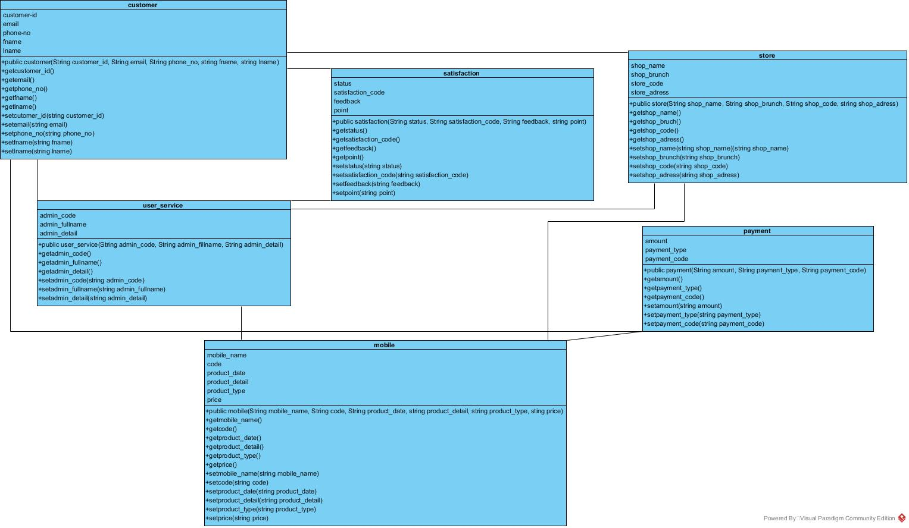

A Class Called customer is designed as shown in the class diagram, it contains:

* five Private Member customer_Id (string), email (String), Phone_no (string), fname (string),lname(string)
* A Default constructor
* Public Getter / Setters: getcustomer_Id (), getemail(), getphone_no(), getfname(),getlname()

, setcustomerId (string customer_id), setemail(string email), setPhone_no (string phone_no), setfname (string fname),setlname(string lname)

* customer= new ArrayList();
* add_customer(“customer_id”,”email”,”phone_no”,”fname”,”lname”)
* delete_customer(“customer_id”,”email”,”phone_no”,”fname”,”lname”)
* edit_customer (“customer_id”,”email”,”phone_no”,”fname”,”lname”)
* list_customer(“customer_id”,”email”,”phone_no”,”fname”,”lname”)

A Class Called user_service is designed as shown in the class diagram, it contains:

* three Private Member admin_code(string), admin_fullname(String), admin_detail(string)
* A Default constructor
* Public Getter / Setters: getadmin_code (), getadmin_fullname(), getadmin_detail()

,setadmin_code (string admin_code), setadmin_fullname (string admin_fullname), setadmin_detail(string admin_detail)

* User_service= new ArrayList();
* add_ User_service (“admin_code”,”admin_fullname”,”admin_detail”)
* delete_ User_service (“admin_code”,”admin_fullname”,”admin_detail”)
* edit_ User_service (“admin_code”,”admin_fullname”,”admin_detail”)
* list_ User_service (“admin_code”,”admin_fullname”,”admin_detail”)

A Class Called payment is designed as shown in the class diagram, it contains:

* three Private Member amount(string), payment_type(String),payment_code(string)
* A Default constructor
* Public Getter / Setters: getamount (), getpayment_type(), getpayment_code()

,setamount(string amount), setpayment_type(string payment_type), setpayment_code(string payment_code)

* payment= new ArrayList();
* add_ payment (“amount”,”payment_type”,”payment_code”)
* delete_ payment (“amount”,”payment_type”,”payment_code”)
* edit_ payment (“amount”,”payment_type”,”payment_code”)
* list_ payment (“amount”,”payment_type”,”payment_code”)

A Class Called mobile is designed as shown in the class diagram, it contains:

* six Private Member mobile_name(string), code (String), product_date (string), product_detail (string),product_type(string),price(string)
* A Default constructor
* Public Getter / Setters: getmobile_name (), getcode(), getproduct_date (), getproduct_detail(),getproduct_type (),getprice()

, setmobile_name (string mobile_name), setcode(string code), setproduct_date (string product_date), setproduct_detail (string product_detail),setproduct_type (string product_type) ,

Setprice(string price)

* mobile = new ArrayList();
* add_mobile(“mobile_name”,”code”,”product_date”,”product_detail”,”product_type”,”price”)
* delete_ mobile (“mobile_name”,”code”,”product_date”,”product_detail”,”product_type”,”price”)
* edit_ mobile (“mobile_name”,”code”,”product_date”,”product_detail”,”product_type”,”price”)
* list_ mobile (“mobile_name”,”code”,”product_date”,”product_detail”,”product_type”,”price”)

A Class Called store is designed as shown in the class diagram, it contains:

* four Private Member shop_name (string), shop_bruch(String),shop_code(string), shop_address (string)
* A Default constructor
* Public Getter / Setters: getshop_name (), getshop_bruch(), getshop_code(), getshop_address()

, setshop_name (string shop_name), setshop_bruch (string shop_bruch), setshop_code(string shop_code), set shop_address(string shop_address)

* store= new ArrayList();
* add_ store (“shop_name”,” shop_bruch”,” shop_code”,” shop_address”)
* delete_ store (“shop_name”,” shop_bruch”,” shop_code”,” shop_address”)
* edit_ store (“shop_name”,” shop_bruch”,” shop_code”,” shop_address”)
* list_ store (“shop_name”,” shop_bruch”,” shop_code”,” shop_address”)

A Class Called satisfaction is designed as shown in the class diagram, it contains:

* four Private Member status (string), satisfaction_code(String),feedback(string), point (string)
* A Default constructor
* Public Getter / Setters: getstatus(), getsatisfaction_code(), getfeedback(), getpoint()

, setstatus (string status), setsatisfaction_brunch(string satisfaction_brunch), setfeedback(string feedback), setpoint(string point)

* satisfaction= new ArrayList();
* add_ satisfaction (“status”,” satisfaction_code”,”feedback”,”point”)
* delete_ satisfaction (“status”,” satisfaction_code”,”feedback”,”point”)
* edit_ satisfaction (“status”,” satisfaction_code”,”feedback”,”point”)
* list_satisfaction (“status”,” satisfaction_code”,”feedback”,”point”)